STATEMENT OF ARCHBISHOP DIARMUID MARTIN
ON THE DEFENCE OF HUMAN LIFE

“The Church must always be Pro-Life”
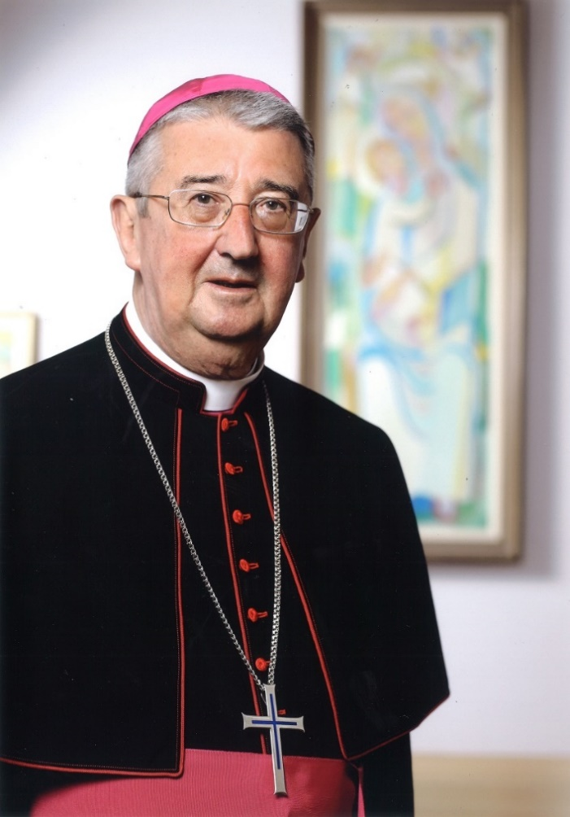

The Church must always be pro-life. That means that the Christian community must be a beacon of support for life especially at its most vulnerable moments and a beacon of support at vulnerable moments of any woman or man along their path of life.

Christians must be pro-life when it comes to the unborn and those who are vulnerable at the end of their lives.

The Church must be pro-life at many other moments in the lives of people. Being pro-life means recalling all of us to reflect on the deeper meaning of life and to reject many of the paths of superficiality that lead away from true human fulfilment.

The Church is called to be pro-life not just in words and statements and manifestoes but to be pro-life in deeds, by being a Church which reflects the loving care of Jesus for human life at any stage. That loving care includes support to help those women who face enormous challenges and who grapple with very difficult decisions to choose life.

Being Pro-life means protecting and loving every human being. There are no second-class humans worthy of less protection and care than others are.

For too long, a mentality was common in Ireland in which single mothers were ostracised and humiliated. This narrow moralistic culture was often sadly enhanced by the attitude of the Church.

It was women who stood up and challenged that culture and affirmed their desire and right to be able to keep and give love to their children. We owe a debt to those women who, then and now, witness to life. It is still not easy to be a lone parent and we have to create an environment to ease the obstacles and burdens of lone parents and their children.

Ireland has a great record in the care of mothers and of children. The overall ethos of medicine in Ireland has been marked by a passionate commitment to do all to protect the life of both mother and child.

The 8th Amendment to the Constitution sets out to ensure equal protection of both the mother and the unborn child. The Amendment ought to have been accompanied by an appropriate legislative framework to assist doctors in dealing with complex situations. This is still possible.

Repealing the Eighth Amendment is not about permitting limited abortion. It would bring about a radical change to our broad pro-life culture. It would end any Constitutional protection whatsoever for the unborn. Proposed future legislation would permit abortion without restriction up to 12 weeks, but also permit abortion on physical and mental health grounds up to six months.

How abortion legislation evolves into the future would be left entirely to the Oireachtas without any Constitutional framework within which legislation can be set. In future it is possible, that small minority parties of a coalition government could demand that abortion legislation be extended as part of a programme for government.

Future legislation regarding abortion could become the sole prerogative of an Oireachtas in a future culture that could be desensitised if abortion became more frequent. This has been the experience in many other countries.

Repealing the 8th Amendment in such circumstances means that the rights of the unborn would definitively left without Constitutional protection. It would be a point of no return. I ask you to reflect on that.

It seems incongruous that just as medical science allows us to understand much more about the evolution of the baby in the womb and his or her originality and unique identity that we should simply throw out all Constitutional protection of the unborn child. For that reason I will be voting No.

I ask the Catholic community in the Archdiocese of Dublin to join in moments of prayer in the coming days in each parish. I ask you to invoke the Spirit of Jesus to touch hearts and commit our society to be pro-life in defending the lives of unborn children and in supporting women and men in the challenges they meet in accepting the joy of parenthood.

16th May 2018.

